Earthquest Inc

A Non-Profit 501-C3 Organization

Email: Earthquestorg@gmail.com
Primary Phone: (706) 457-1449
Secondary Phone: (540) 718-4018

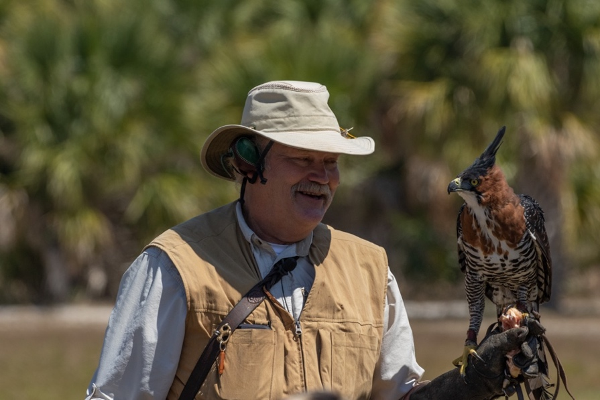
Earthquest is a non-profit organization that utilizes non-releasable birds of prey to educate others with the struggle’s wildlife face in our modern age. Seeing our birds up close and personal is a great way for people to appreciate how their actions affect the environment. Earthquest has over 30 years of experience and is known as one of the premier programs in the United States.
In our demonstration, your guests or students will see lots of different raptors. We have a large variety of native and exotic birds. They are all acquired though rehabilitation programs and breeding projects. All of our birds are considered
Our founder, Steve Hoddy, working with Earthquest's Ornate Hawk-Eagle at one of our demonstrations
non-releasable.
In our program your guests or students will learn what makes these raptors different from other birds. This ability to see the raptors up close while learning about them is what makes such a lasting effect. We have no doubt your guests or students will be talking about the birds for years to come.
In our program; Steve Hoddy, our founder, Master Falconer and environmentalist or Don
McCullough, Master Falconer, provides information on the birds, their environment, and how we can
responsibly interact with nature.
Contact today to schedule Earthquest at your event or school!

Contact Information

Our primary form of communication is email, which is checked often. You can expect a follow up within 24
hours of your initial email.

Email Address: Earthquestorg@gmail.com
Primary Phone: Steve Hoddy (706) 457-1449
Secondary Phone(s):
Robert Haynes (540) 718-4018
Don McCullough (334) 441-6677

